Lab: PMML in DSX

November 30th, 2017

Author: Elena Lowery elowery@us.ibm.com
Table of contents
Contents
Overview 1
Required software, access, and files 1
Part 1: Create a DSX Project and Load Data 1

Overview
In this lab you will learn how to import PMML files into DSX and configure them for scoring.

Required software, access, and files
- To complete this lab, you will need access to a DSX Local cluster.
- You will also need to download and unzip this GitHub repository: https://github.com/elenalowery/DSX_Local_Workshop

Part 1: Create a DSX Project and Load Data

- Log in to a DSX Local cluster and create a project. You can provide any name. In DSX Local project names must be unique within in a cluster. For example, add initials to the name of your project.

- Switch to the Assets tab. Scroll to Models and click on add model. Provide model name (add your initials so that it’s easier to find on a shared cluster).

- Click Browse. Navigate to the PMML/PMML Files folder of the unzipped GitHub repository and select SPSS_ResponseChannel.xml. Click Create.

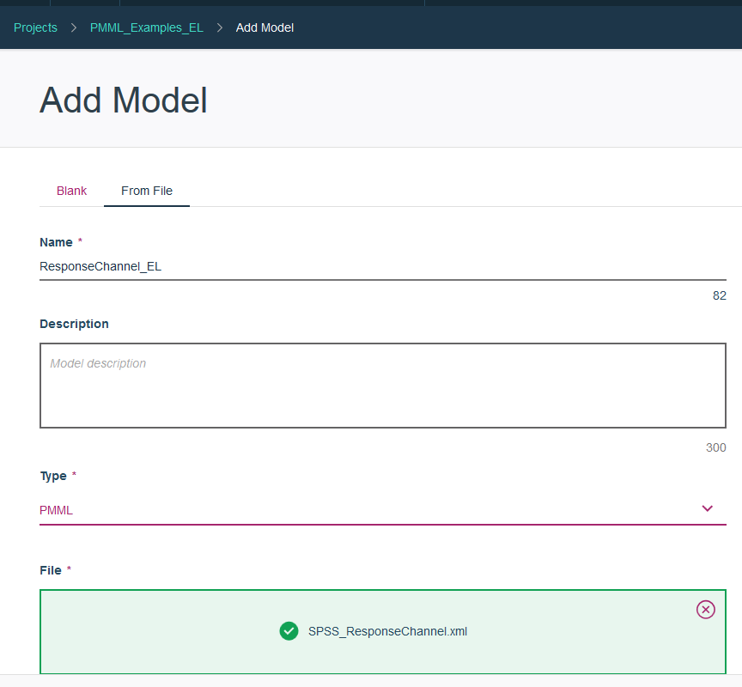

- Navigate to the Model Management dashboard and click on Models.

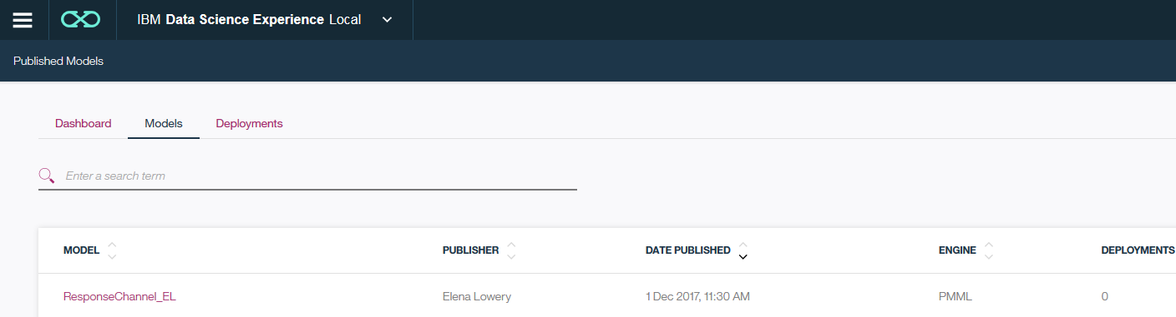

- Click on the ellipses and select Deploy. Provide deployment name and click Create.

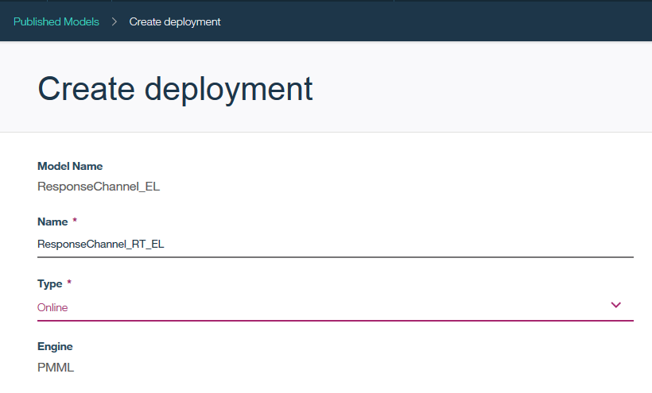

- The deployed model is displayed in the Deployments tab.

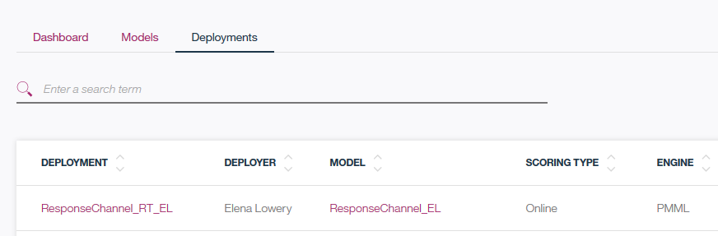

- We will test model deployed with a Notebook. Navigate to the Projects view, open the PMML project that you created, and create a new notebook from file. Browse to the PMML/Notebooks folder of the unzipped GitHub repository and import PMMLTestClient.ipynb.

- Replace hostname, endpoint and userid/password as indicated in the notebook and run it. The prediction is the last field (Mobile in the screenshot).

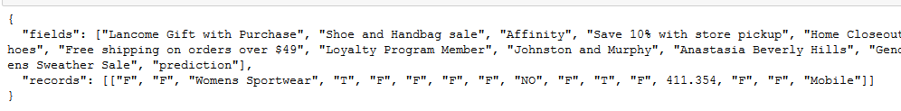

If you wish, you can change input data to the following:

12582,"M","Mens Sportswear",256.014000,"NO","Email",25601.400000,"T","T","F","F","F","F","T","T","F","T","F"

Then the prediction is to contact the customer via direct mail.

You have finished PMML in DSX Local lab.

